DIGITAL IMAGE PROCESSING ASSIGNMENT-1

SANTOSH KRISHNA-1PE16EC137

UTSAV ROY-1PE16EC167

VISHAL MALEKAR-1PE16EC177

Q1.Find number of rows and columns of image and find the data for the pixel in the fifth row and second column

Soln.

The code is the following:

image=imread('lena.png');

disp('the size of image is:');

disp(size(image));

imshow(image);

y=impixel(image,5,2);

disp('the required pixel is');

disp(y);

The result is as follows:

the size of image is:

220 220 3

the required pixel is

226 134 122

The snapshot for the same is as follows:

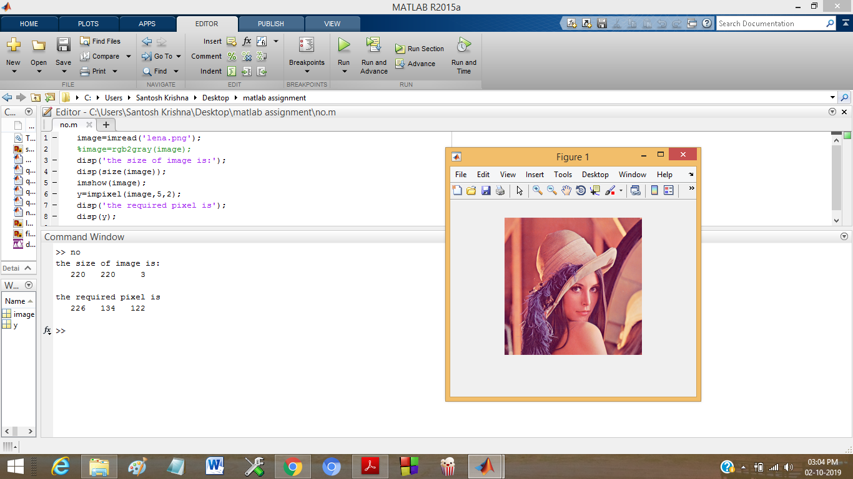

Q2: Write the program that produces mirror image of the image and display both the original

and mirror images.

Soln:

The code for the same is as follows:

x=imread('lena.png');

imshow(x);

title 'original image'

flipped=flipdim(x,2);

figure

imshow(flipped);

title 'mirror image'

The resulting images are:

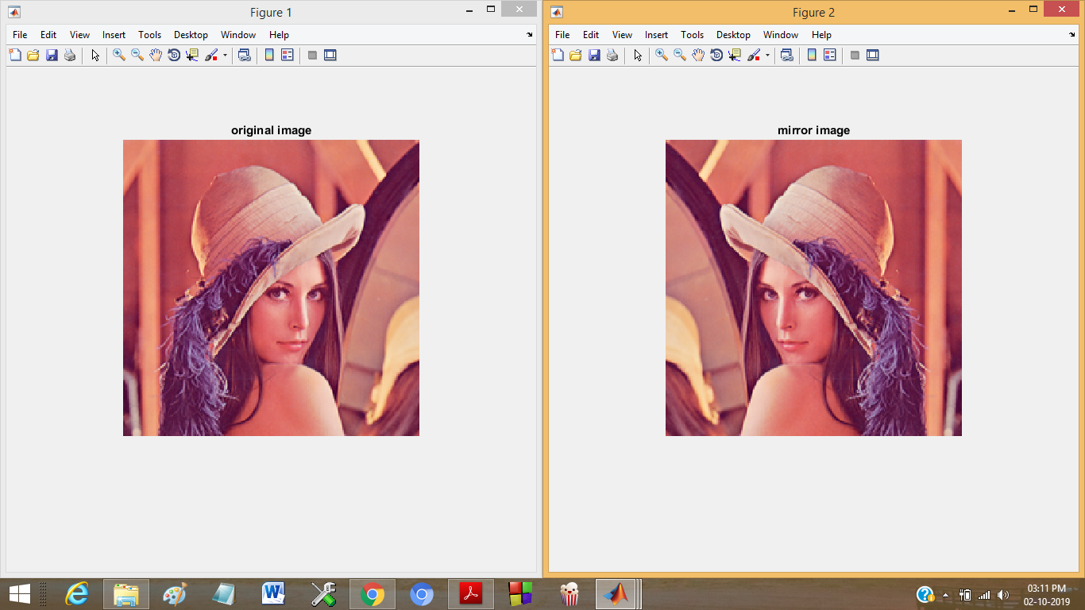

Q3 Write a MATLAB code that will do the following

a) Read any gray scale image.

b) Display that image.

c) Again display the image such that the pixels having intensity values below 50 will

display as black and pixels having intensity values above than 150 will display as

white. And the pixels between these will display as it is.

Soln:

The algorithm involves reading an image and then employing a for loop which checks each pixel value and reassigns it as per requirement.

The code that performs the above is:

image=imread('lena2.jpg');

imshow(image);

title 'original image'

[r,c]=size(image);

fina=zeros(r,c);

for i=1:r;

for j=1:c;

if image(i,j)<50

fina(i,j)=0;

else if image(i,j)>=50 && image(i,j)<150

fina(i,j)=image(i,j);

else if image(i,j)>150

fina(i,j)=255;

end

end

end

end

end

figure

imshow(fina);

title 'operated image'

The snapshot is as follows

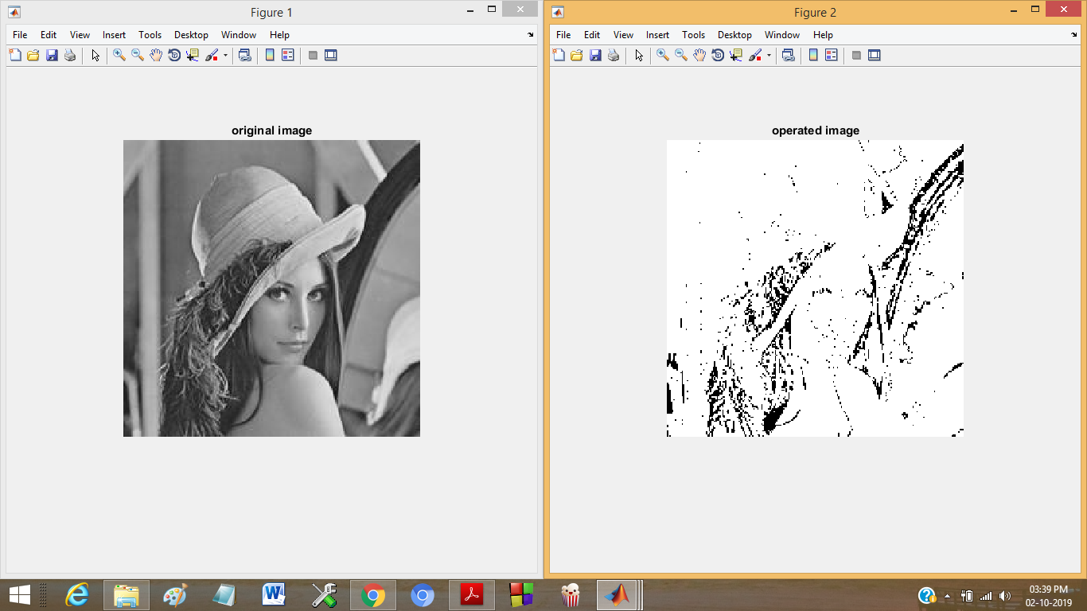

Q4.Read an image and reduce the resolution of image by four. Display both the original and new image with original size.

Soln

The code that performs the above is as follows

image=imread('lena.png');

image=rgb2gray(image);

imshow(image);

title 'original'

figure

resize1=imresize(image,(1/4));

imshow(resize1);

title 'operated'

The snapshot is as follows:

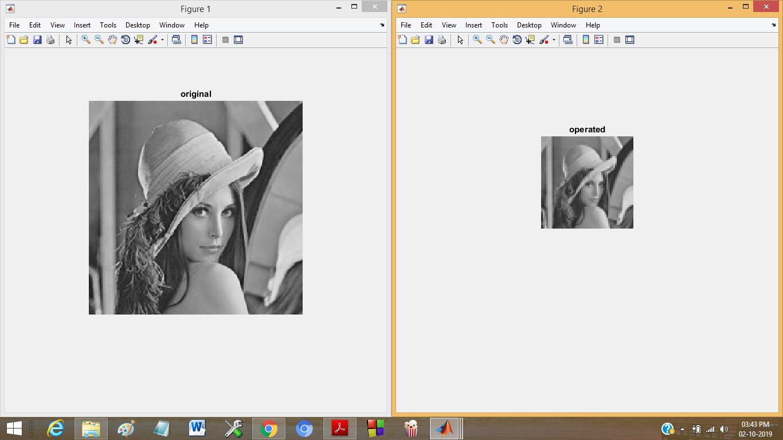

Q5.Read an image and reduce the quantization level to 64 and16 gray levels and display result in same window.

Soln.

The algorithm is to divide each pixel value by 16/4 to reduce the max value from 255 to 64 or 16 as per requirement.

The code is as follows

image=imread('lena.png');

image=rgb2gray(image);

imshow(image);

title 'original'

im16=image/16;

im4=image/4;

figure

imshow(im16,[])

title '16 quantization levels'

figure

imshow(im4,[])

title '64 quantization levels'

The snapshot is as follows

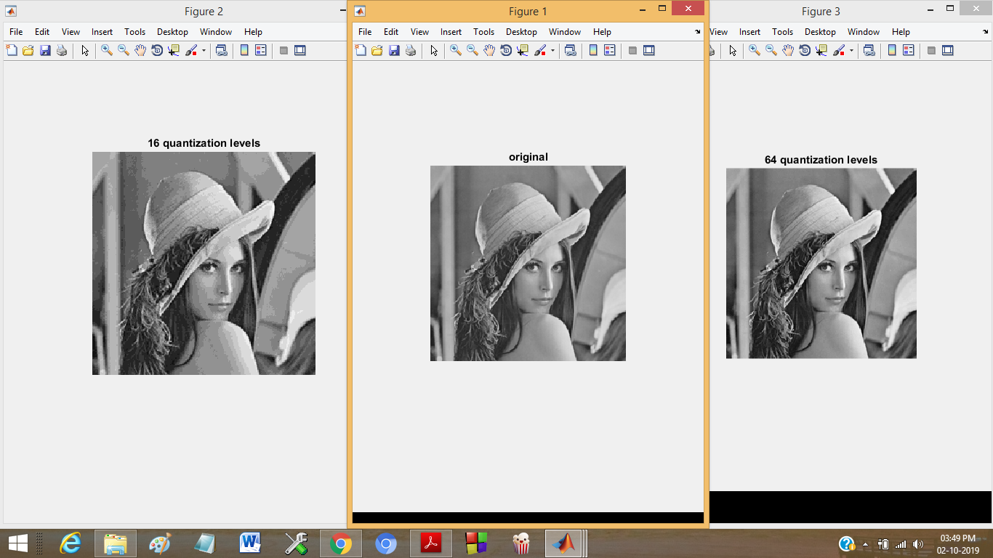

Q6. 6. Take two images and perform following operations and display:

a) Add two images

Soln.

The code to perform the addition is

x=imread('lena2.jpg');

y=imread('fina1.jpg');

z=imadd(x,y);

figure

imshow(x);

title 'one'

figure

imshow(y);

title 'two'

figure

imshow(z);

title 'sum'

The snapshot is as follows

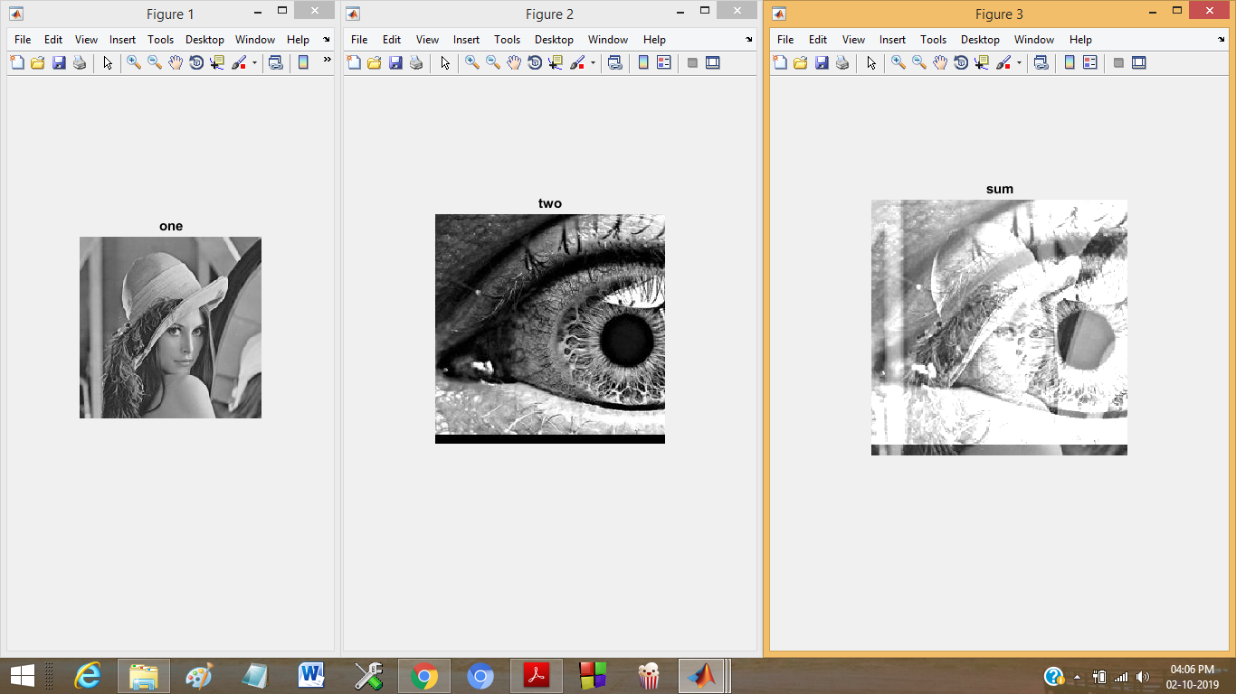

Q6b) Find absolute difference of two images

Soln. The code is

x=imread('lena2.jpg');

y=imread('fina1.jpg');

z=imabsdiff(x,y);

subplot(1,3,1);

imshow(x);

subplot(1,3,2);

imshow(y);

subplot(1,3,3);

imshow(z);

The snapshot is

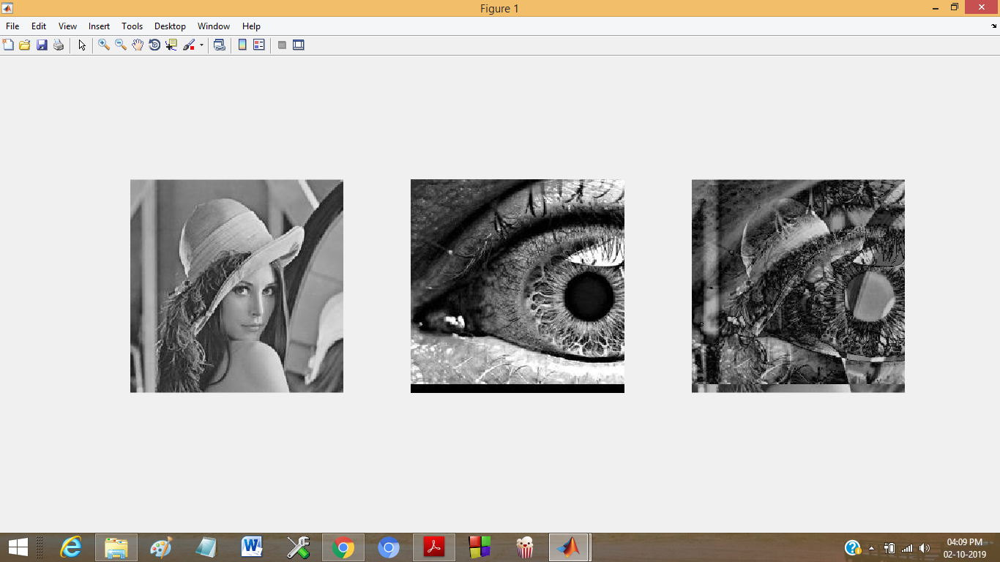

Q6c) Divide two images

Soln.

Code for the same is

x=imread('lena2.jpg');

y=imread('fina1.jpg');

z=imdivide(x,y);

subplot(1,3,1);

imshow(x);

subplot(1,3,2);

imshow(y);

subplot(1,3,3);

imshow(z);

Snapshot is

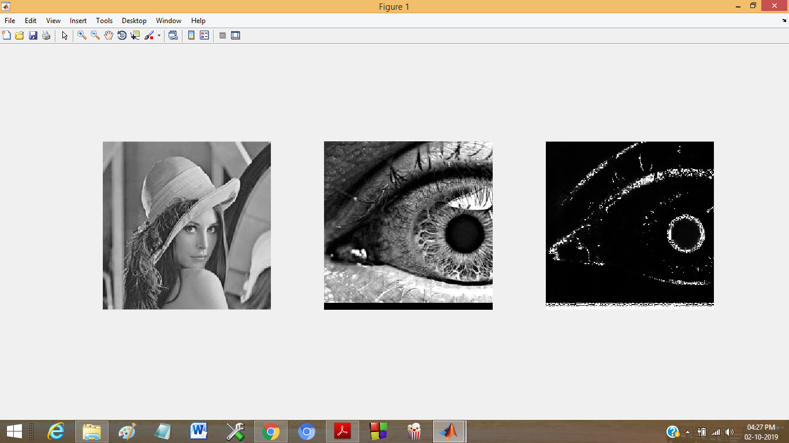

Q6d)

Soln.

The code for the same is

x=imread('lena2.jpg');

y=imread('fina1.jpg');

z=imsubtract(y,x);

subplot(1,3,1);

imshow(x);

subplot(1,3,2);

imshow(y);

subplot(1,3,3);

imshow(z);

The snapshot is

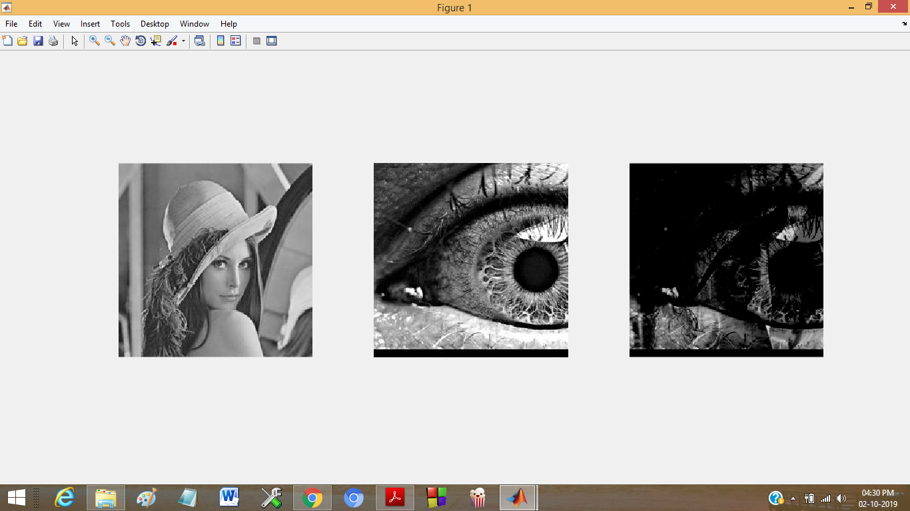

Q6E)Add the images using linear combinations. Specify the output as type uint16 to avoid

truncating the result.

Soln.

The code for the same is

x=imread('fina1.jpg');

y=imread('lena2.jpg');

z=imlincomb(1,x,1,y,'uint16');

imshow(z,[]);

The snapshot of the same is

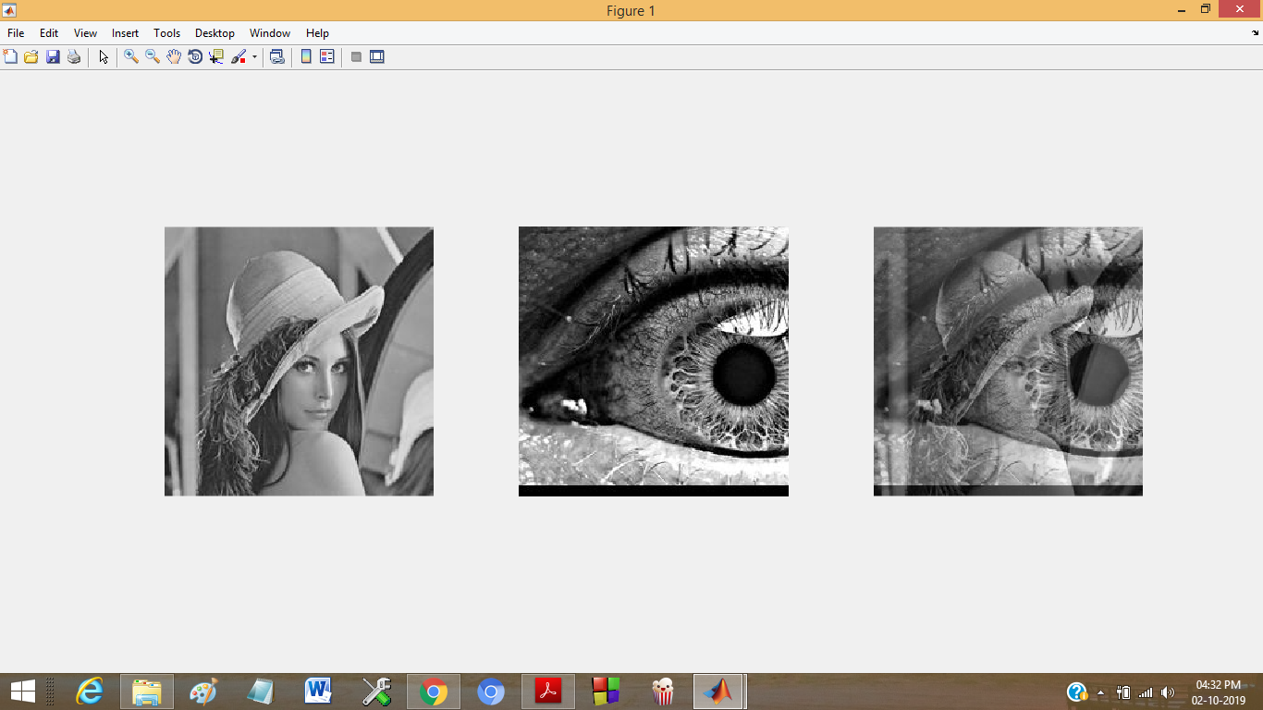

Q6.F)Find complement of images and add.

Soln.

The code that does is

image=imread('fina1.jpg');

image1=imread('lena2.jpg');

d=imcomplement(image);

o=imcomplement(image1);

s=imadd(d,o);

subplot(1,3,1);

imshow(d);

subplot(1,3,2);

imshow(o);

subplot(1,3,3);

imshow(s);

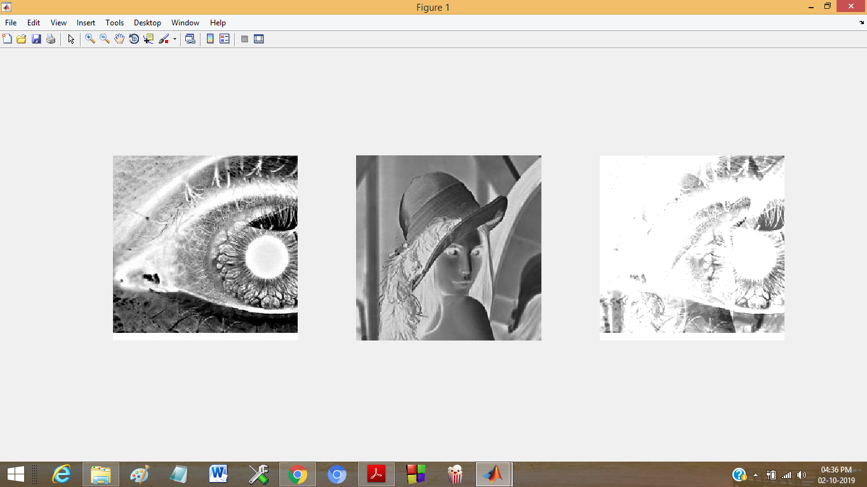

Q6G)Multiply any image by itself.

Soln.

The code is

x=imread('fina1.jpg');

y=imread('lena2.jpg');

z=immultiply(x,y);

subplot(1,3,1);

imshow(x);

subplot(1,3,2);

imshow(y);

subplot(1,3,3);

imshow(z);

The snapshot is

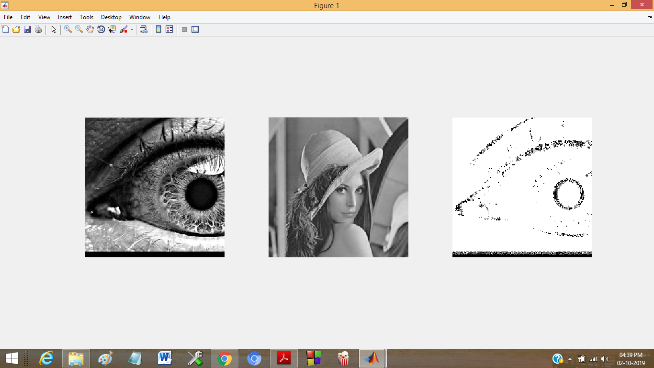

Q7.Perform the following on test images of Lena, Barbara, Cameraman and Goldhill

a) Zooming by a factor of 2 and 3 using nearest-neighbour interpolation, bilinear

interpolation and bicubic interpolation methods

Soln:

The zooming on lena is as follows:

Code:

image=imread('lena2.jpg');

imshow(image);

title('original');

figure

im=imresize(image,2,'nearest');

imshow(im);

title('2x near');

im=imresize(image,3,'nearest');

figure

imshow(im);

title('3x near');

%bicubic, the resize function uses bicubic by default

imshow(image);

title('original');

figure

im=imresize(image,2);

imshow(im);

title('2x bicubic');

figure

im=imresize(image,3);

imshow(im);

title('3x bicubic');

%bilinear

imshow(image);

title('original');

figure

im=imresize(image,2,'bilinear');

imshow(im);

title('2x bilinear');

figure

im=imresize(image,3,'bilinear');

imshow(im);

title('3x bilinear');

The snapshots are as follows

Near,lena:

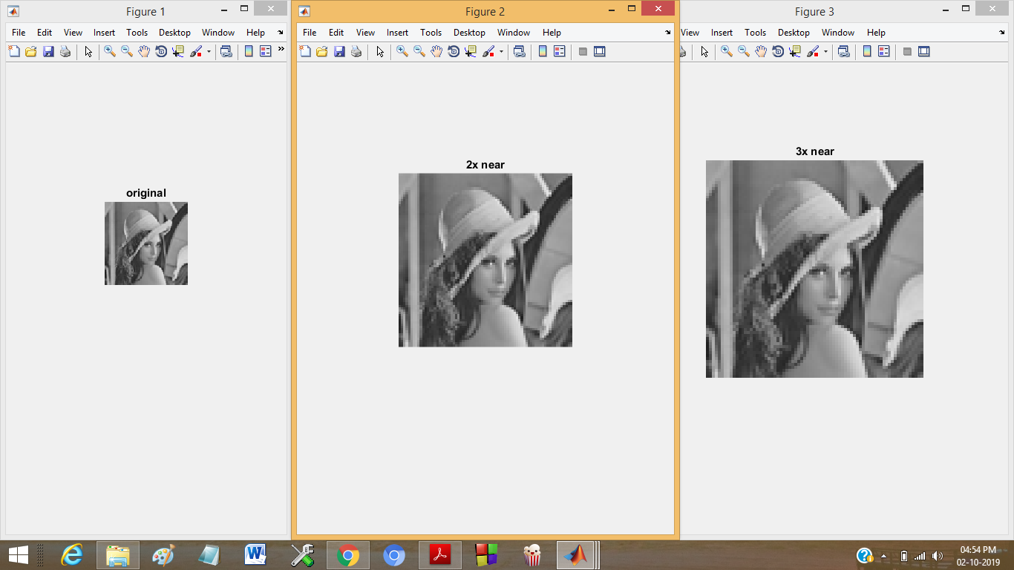

Bilinear,lena

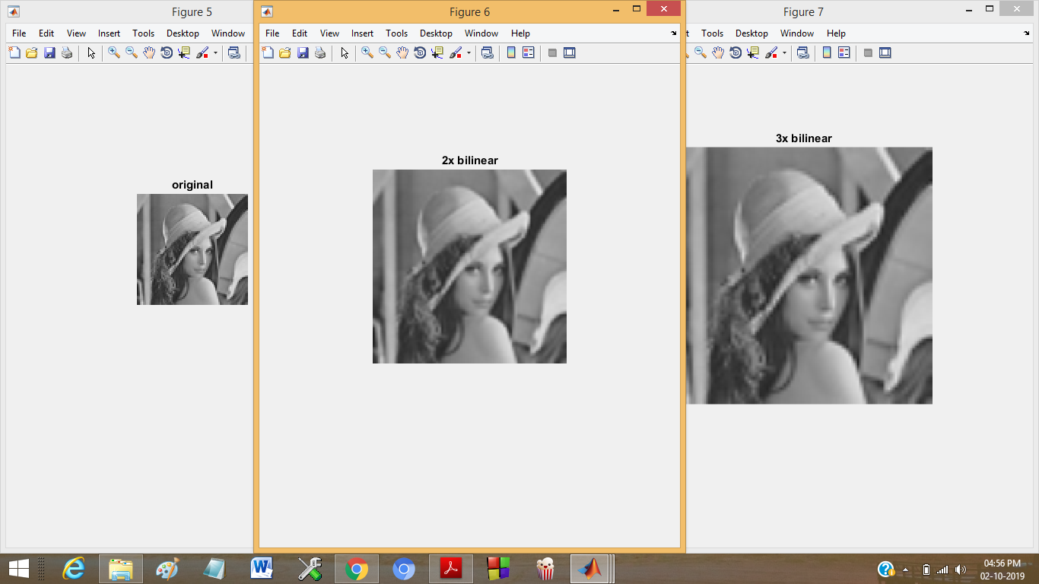

Lena bicubic

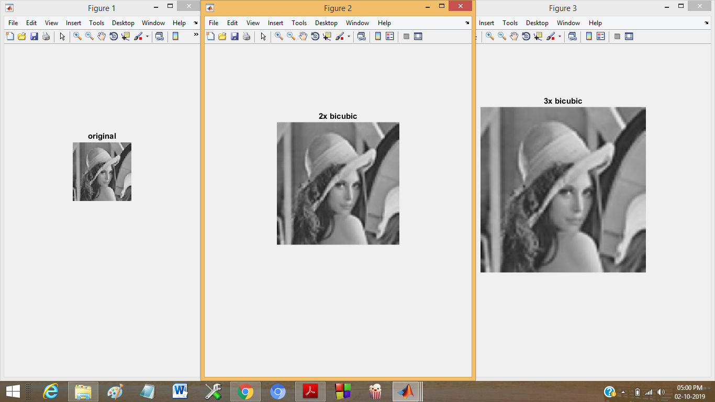

Barbara bicubic

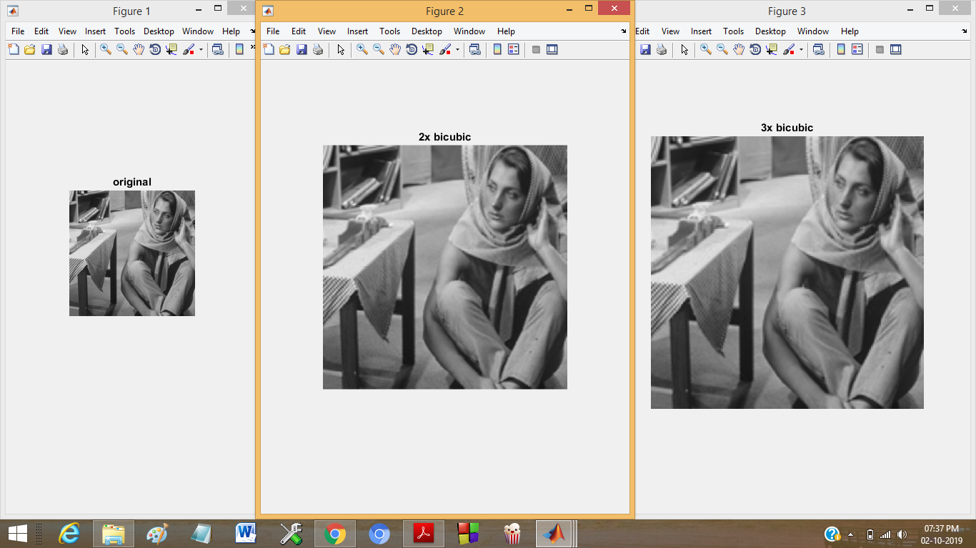

Barbara,near

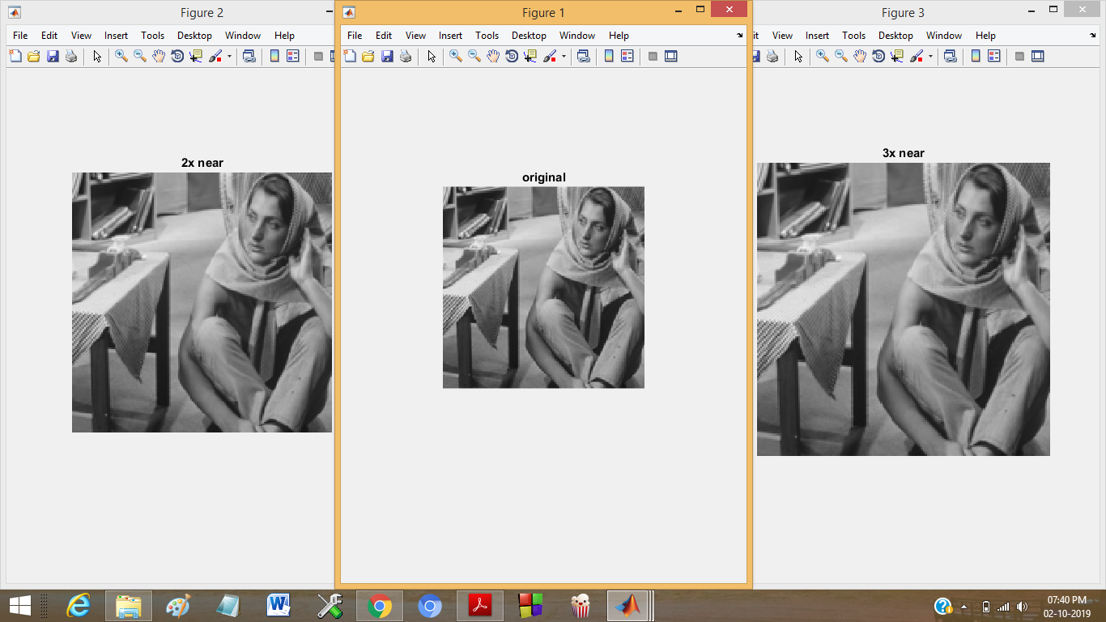

Barbara,bilinear

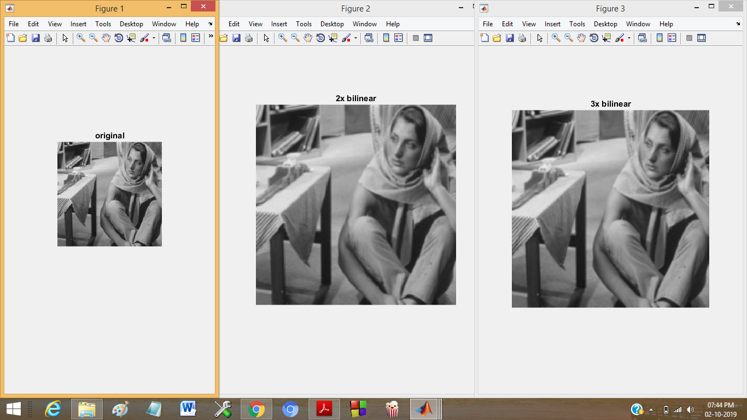

Cameraman,bilinear

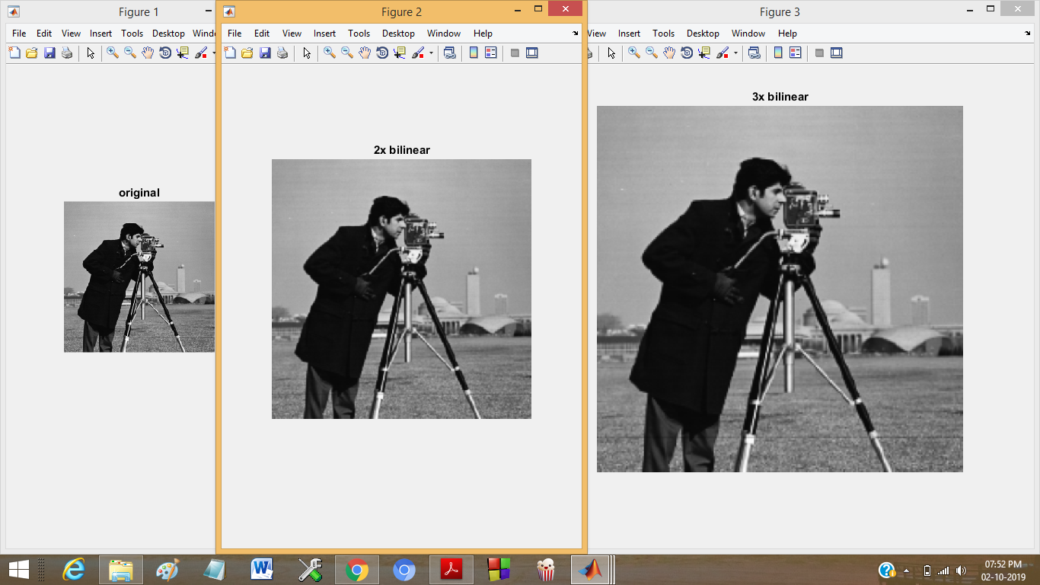

Cameraman,near

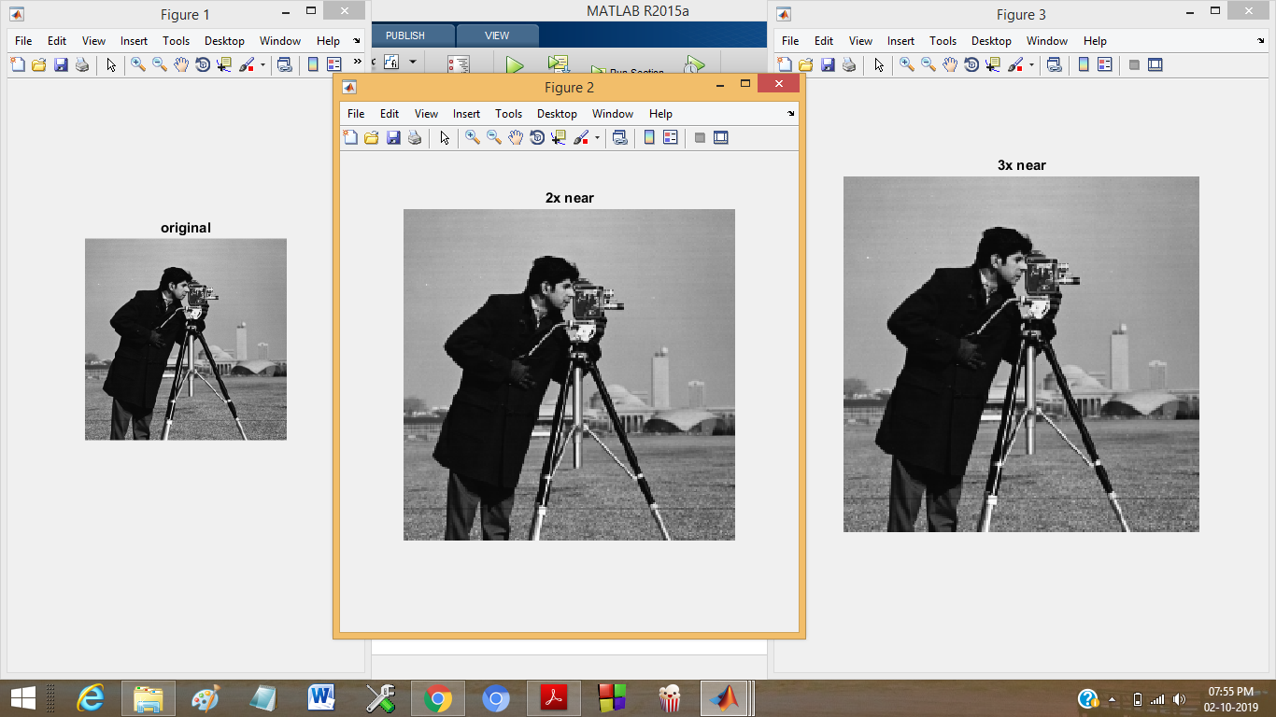

Goldhill,bicubic

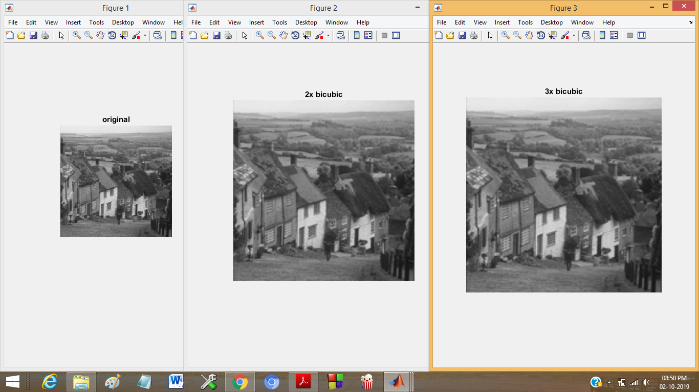

Cameraman,bilinear

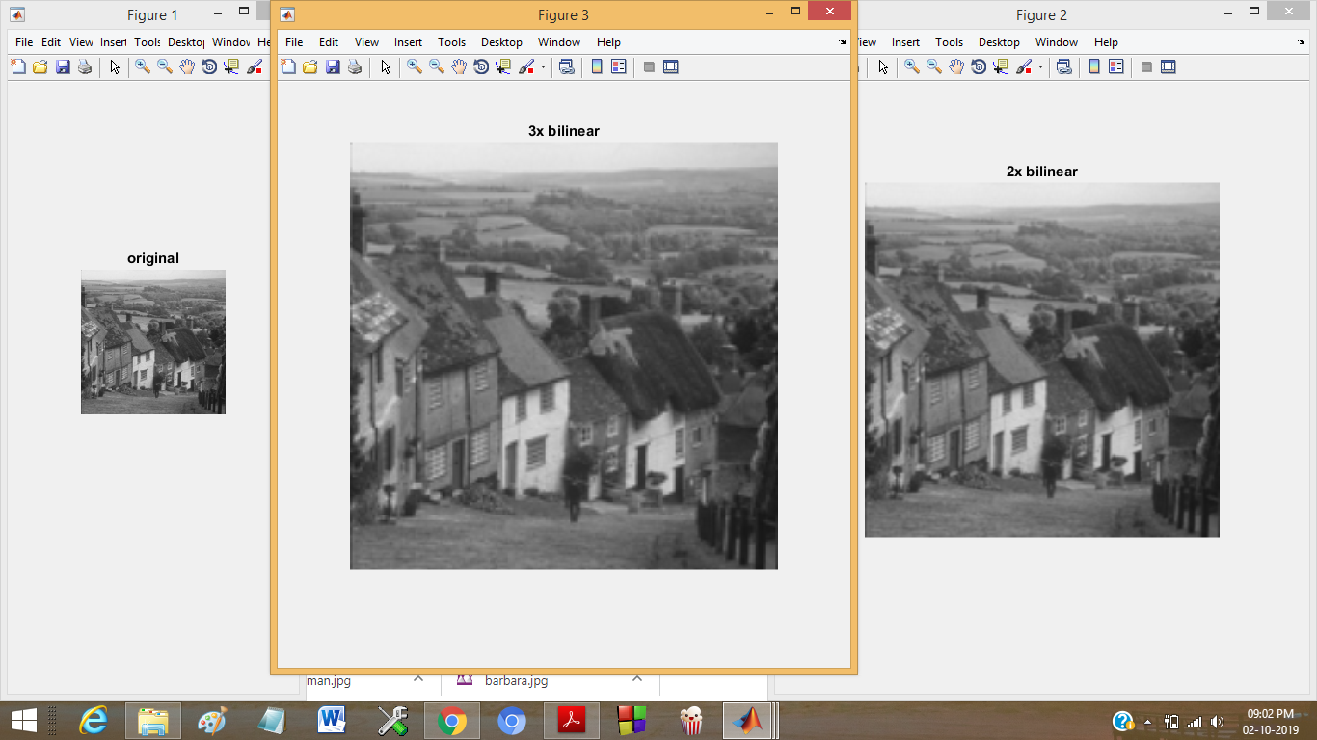

Cameraman,near

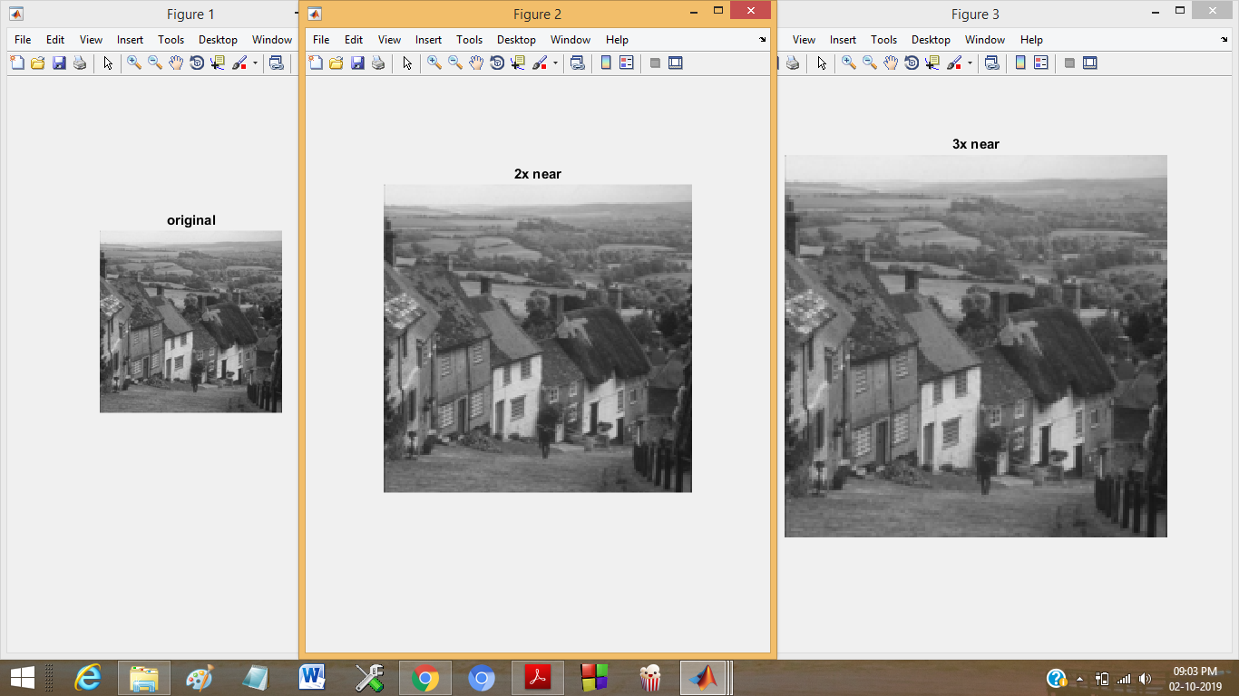

7b)

image=imread('goldhill.jpeg');

imshow(image);

title('original');

figure

im=imresize(image,1/2,'nearest');

imshow(im);

title('2x far');

im=imresize(image,1/3,'nearest');

figure

imshow(im);

title('3x far');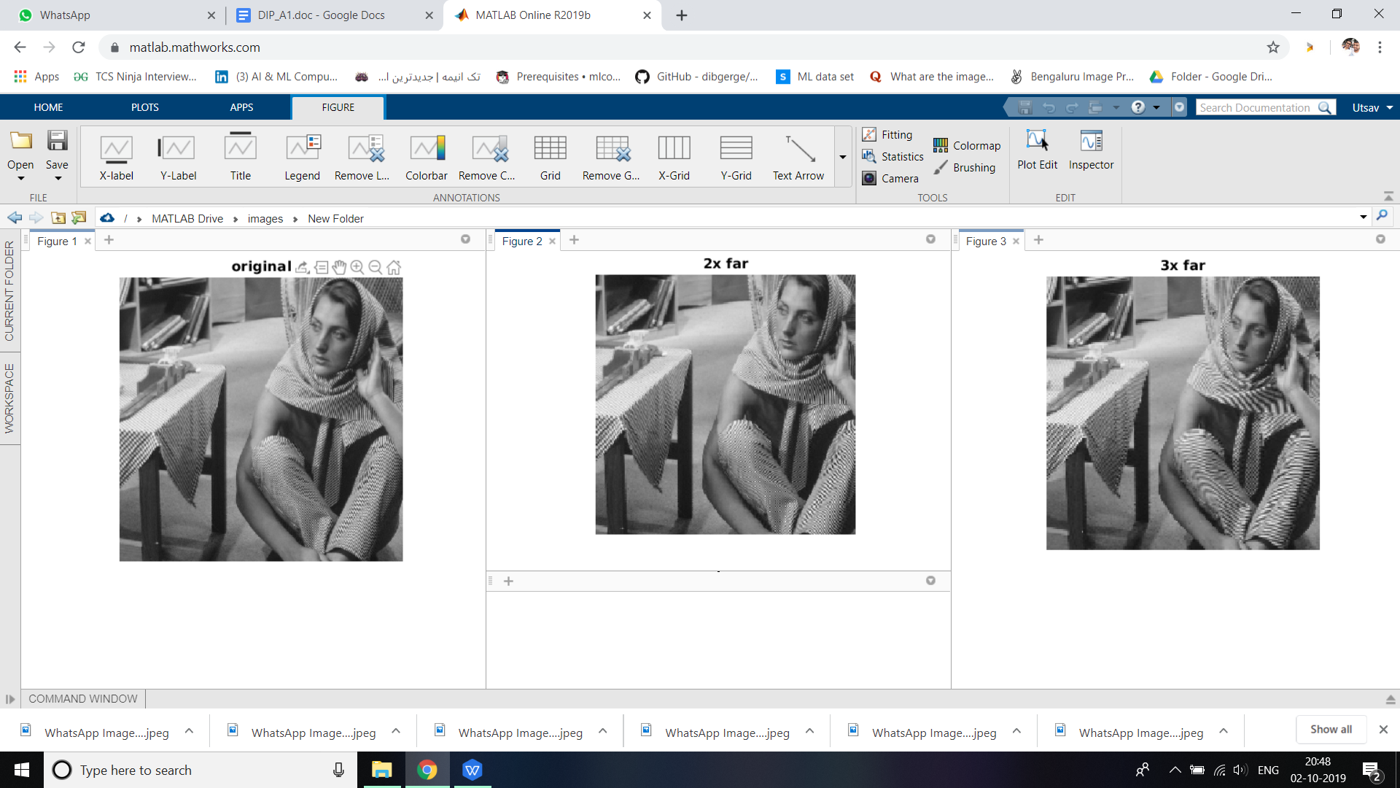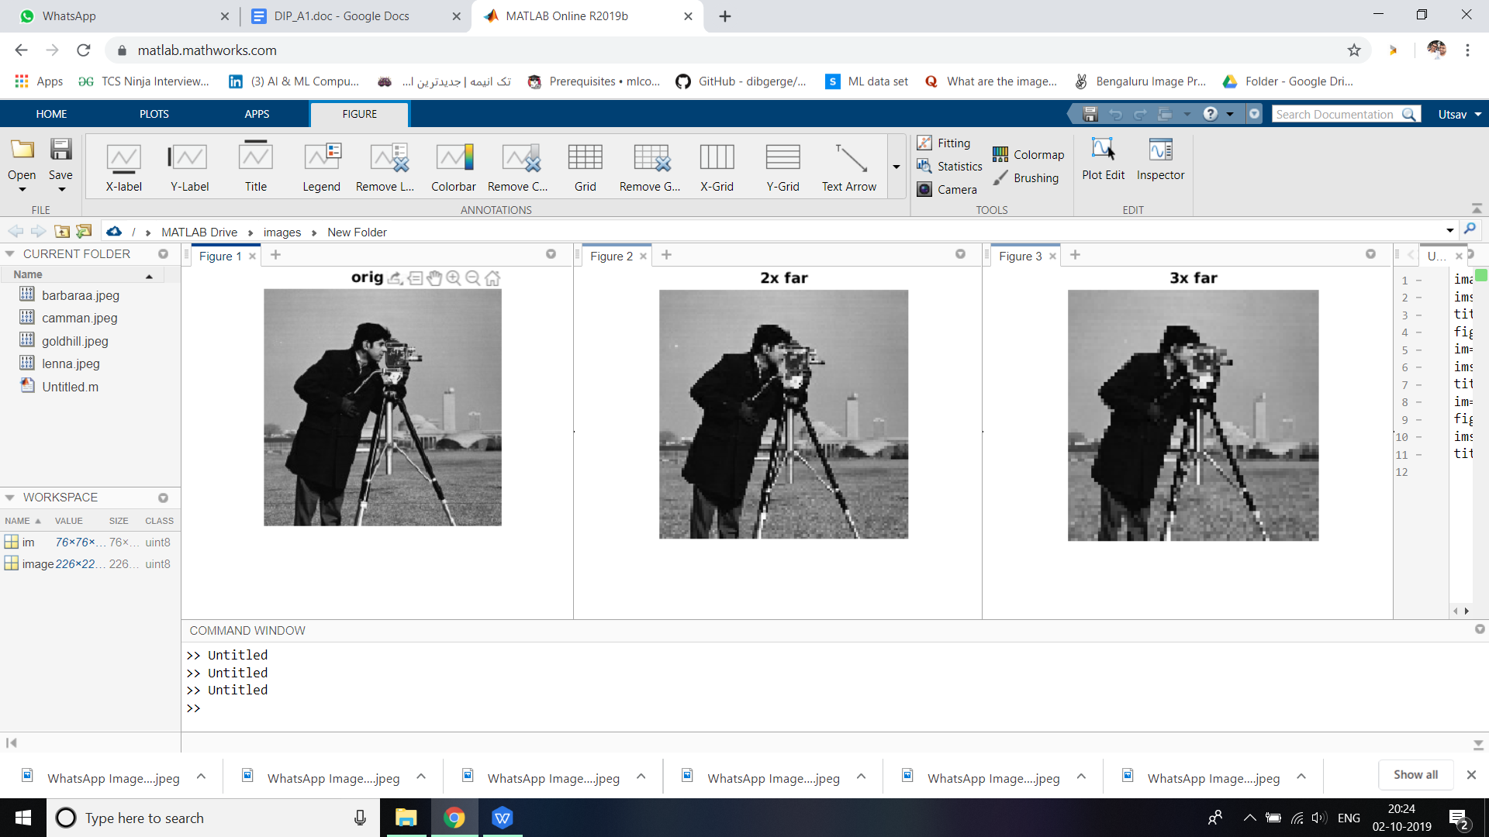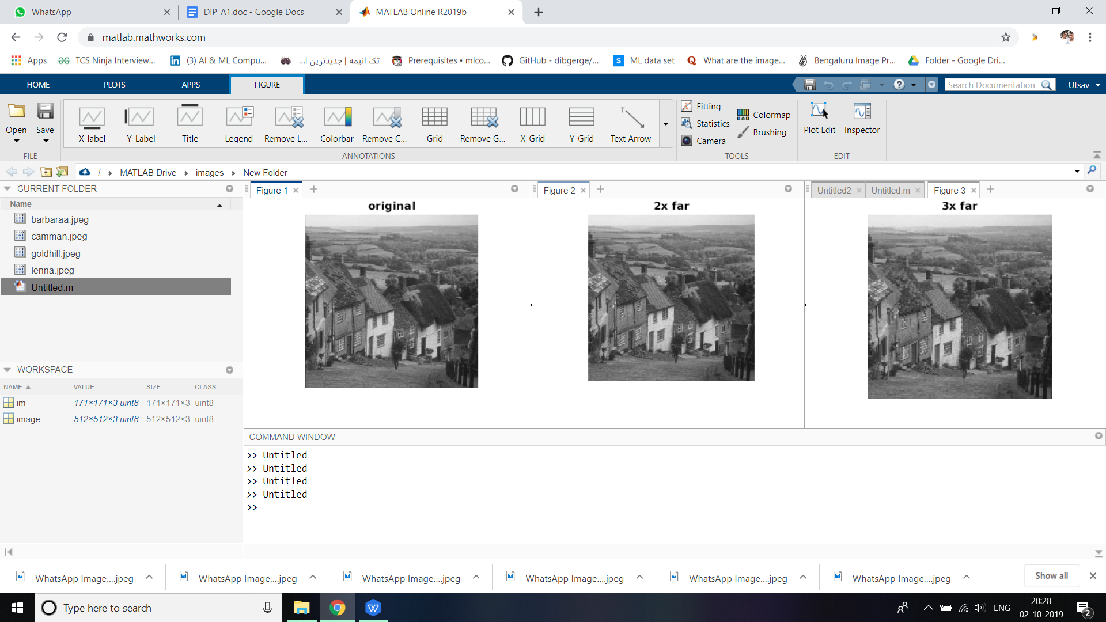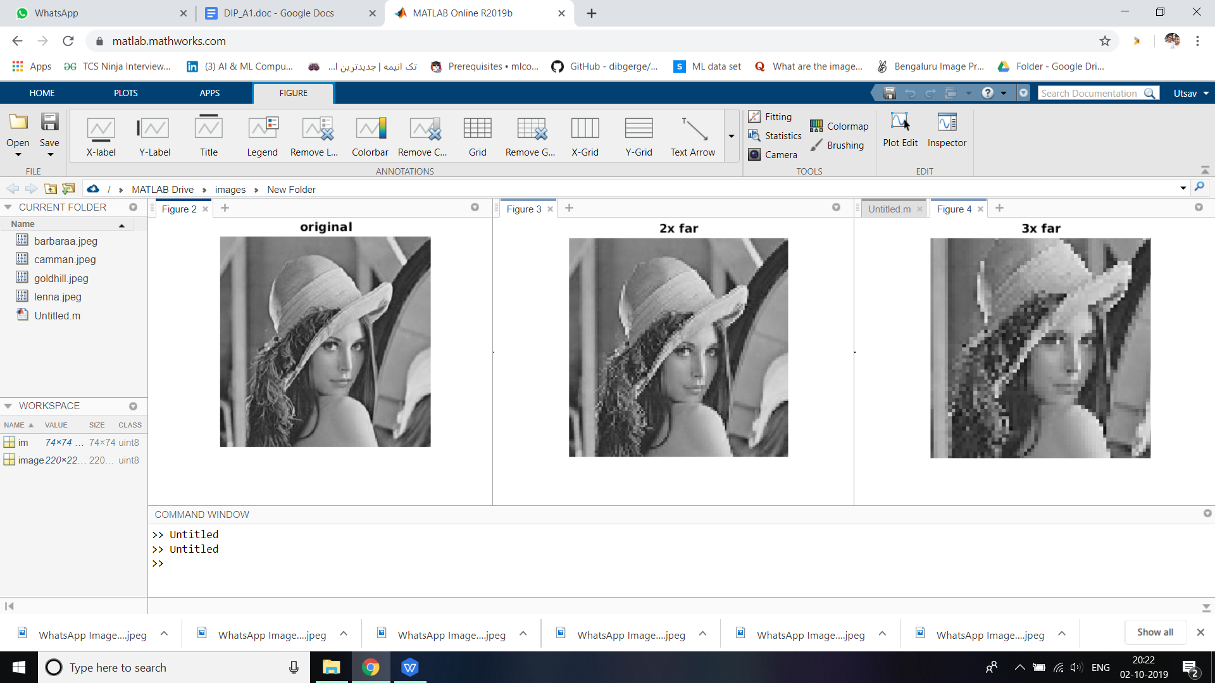

Q8) Perform the following enhancement techniques on test images

a) Contrast stretching using a piece wise linear function

Soln.

i=imread('abc.jpg');

figure(1);

imshow(i);

title('original image');

a=min(x(:));

b=max(x(:));

i=(i-a))

b) Histogram stretching

Soln.

i=imread('abc.jpg');

figure(1);

imshow(i);

title('origin image');

a=min(x(:));

b=max(x(:));

i=(i-a).*(255/(b-a));

figure(2);

imshow(i);

c) Histogram equalization

Soln.

i=imread('barbara.jpg');

figure

subplot(1,2,1);

imshow(i);

subplot(1,2,2);

imhist(i,64);

j=histeq(i);

figure

subplot(1,2,1)

imshow(j);

subplot(1,2,2);

imhist(j,64);

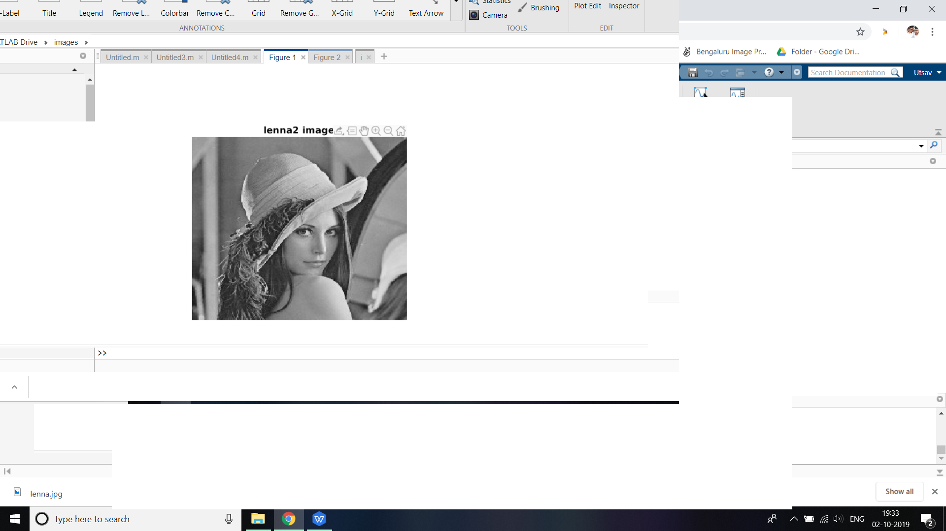

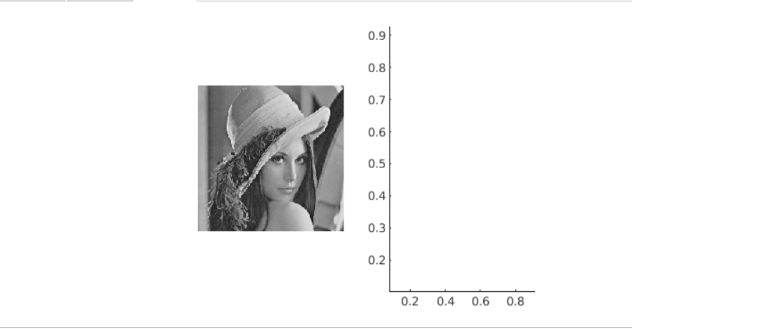

Q9. Perform image smoothing using averaging and median filter. Use an image with salt and pepper noise and a mask of size 5x5.

Soln.

The code is

image=imread('salt_pepper.png');

image=rgb2gray(image);

imshow(image);

title 'original'

h = ones(5,5)/25;

I2 = imfilter(image,h);

figure

imshow(I2)

title 'averaging filter'

image1=medfilt2(image,[5,5]);

figure

imshow(image1);

title 'median filter'

The screenshot is the following

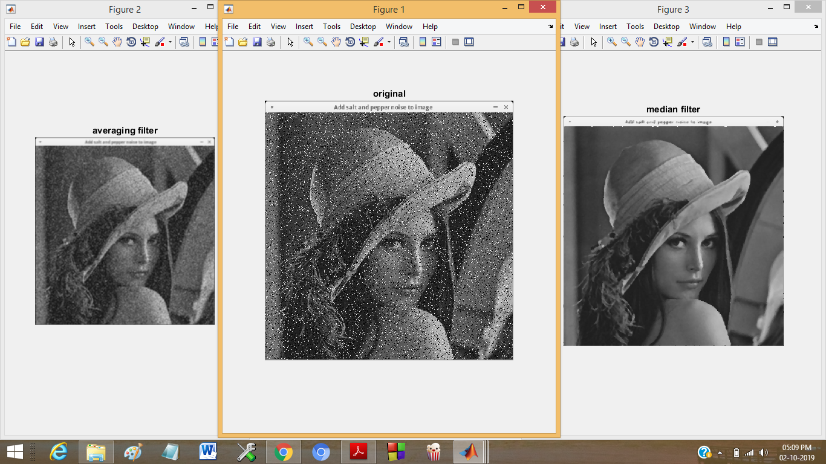

Q 10. Perform highpass filtering using first and second order derivatives on 3 types of images (Low in details, mid detailing and high on details.)

Soln.

First order filter-

a=imread(‘detail.png’);

a=rgb2gray(a);

e1=edge(a,’prewitt’);

e2=edge(a,’sobel’);

e3=edge(a,’roberts’);

figure

subplot(2,2,1);

imshow(a);

title ’original’

subplot(2,2,2);

imshow(e1);

title ‘prewitt’

subplot (2,2,3);

imshow(e2);

title ‘sobel’

subplot (2,2,4);

imshow(e3);

title ‘roberts’

Second order filter-

a=imread(barbara.png’);

f=fspecial(‘laplacian’);

af=filter2(f,a);

figure

subplot(1,2,1);

imshow(a);

title ‘original’

subplot(1,2,2);

imshow(af);

title ‘second order filter’

